
Using Your MPU-60X0 with an LCD Keypad Shield

Overview:
This tutorial demonstrates how to use MPU-60X0s and other I²C devices on a UNO.
Materials:
This project requires an Arduino UNO (or compatible board), a MPU-60X0, an LCD keypad shield, a small breadboard, twelve female/male jumper wires, and a computer with the Arduino IDE installed with a USB connector for the UNO.
Procedure:
1: Wire together the UNO, MPU-60X0, and LCD keypad shield together according to figure 1.

fig. 1
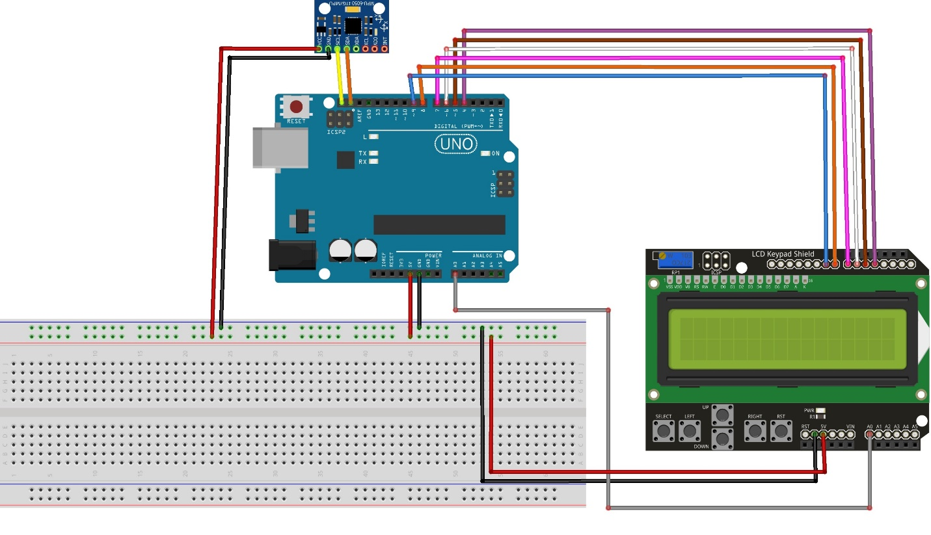

2: Go to www.rabbitrobots.com and download the MPU-60X0 tester program from the “Software” section.
3: Open the MPU60X0Test.ino file with the Arduino IDE and upload it to the UNO.
4: Press the up and down keys to change the type of data being displayed.
5: Press the left and right keys to change the axis.
6: Move and rotate the sensor and observe the position and rotation data displayed on the LCD.

Code explanation:
The first section of the code (fig.2) imports the libraries needed to use the MPU-60X0 and LCD screen, define the program’s constants, declare variables used by the program, and declares the LCD screen in the program.

Fig. 2
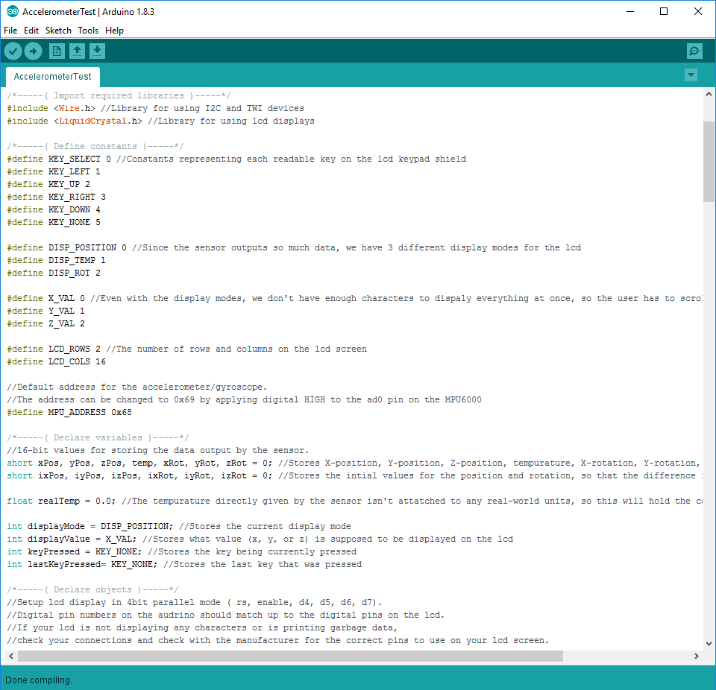

Most of the lines of code in this section deal with managing the LCD keypad shield and determining what data to display, but some are still important to using the MPU-60X0 itself. The line “#include <Wire.h>” imports all of the functions that the program needs to be able to communicate to I²C and other two-wire devices.

The section below that line defines all of the constant the program is going to use with #define. The text after #define is the name of the constant, and value that it represents. Since it has a name and a value, it seems that these constants should be variables, but they are technically called “tokens” and should only be called as such.

The only token being used with the MPU-60X0 is MPU_ADDRESS which is set to 0x68. All I²C devices come with a pre-set address that they can be accessed by a microcontroller. The address can usually be changed on most devices by soldering connectors on the device or applying voltage according to the manufacturer. For example, the MPU-60X0’s address can be changed to 0x69 by applying 5V to its a0 pin. In addition, “0x68” is not the same as the number 68. 0x68 is a hexadecimal number, which uses base-16 instead of decimal which is base-10. What this means is that hexadecimal has 16th and 256th places instead of decimal’s 10th and 100th places. This is done in hexadecimal by having five extra “numbers”, A through F that represent decimal numbers 10 through 15. Figure 3 contains a table demonstrating this concept.

Fig. 3
Dec: | 0 | 1 | 2 | 3 | 4 | 5 | 6 | 7 | 8 | 9 | 10 | 11 | 12 | 13 | 14 | 15 | 16
Hex: | 0 | 1 | 2 | 3 | 4 | 5 | 6 | 7 | 8 | 9 | A | B | C | D | E | F | 10

After the constants of the program are declared, the variables of the program start to be defined. The short and float variable declarations are the only ones relating to reading data from the sensor. short variables take up two bytes or sixteen bits of data in the UNO. This is important because the MPU-60X0 outputs 8-bit data because it needs to be a 16-bit number in order to be used later it is manipulated into the larger data. float variables are special because they can have fractional numbers instead of only integers. In other words, it can hold decimal numbers such as 6.7 where other types of variables like int and short cannot.
In the two lines of short declarations, a total of 13 different variables are declared. One variable for each axis of movement, temperature reading, and the axis of rotation in addition to the second set of variables for each axis of movement and rotation to store the initial values read by the sensor. The float variable declared will hold the temperature read by the device in Celsius, so it needs to be able to hold decimal numbers for accuracy.
The next section of code is the setup() function (fig. 4) that runs once when the UNO starts up. This section initializes the LCD screen and gets the initial data values from the sensor, and wakes up the device by writing specific data to it. The first line of code relevant to the MPU-60X0 is the line “Wire.begin();” This line I²C on the UNO as “master,” meaning that the UNO operates the I2C connection between itself and other devices instead of another I²C device managing the connection for the UNO. The following line, “Wire.beginTransmission(MPU_ADDRESS);” Initiates a connection to the MPU-60X0 to begin writing data with. “Wire.write(0x6B);” makes the connection point to the MPU-60X0’s first power management registry (PWR_MGMT_1). Registries are just slots of data 8 bits long that can either be read from written to or both depending on the specific registry. The first “write” command sent to an I2C device specifies the registry being pointed to, in this case, registry 0x6B.
The second “write” command sent is “Wire.write(0x00);” This clears out the data in the PWR_MGMT_1 registry, and makes the device come out of “sleep” mode. The following line, “Wire.endTransmission();” terminates the connection to the MPU-60X0 and allows other devices to access it since the program has done all it needs to do with the PWR_MGMT_1 registry.
The line “readMPU60X0();” updates the first set of short variables to the data produced by the sensor. An in-depth look at this function will be given later in the document. What is important to note now is that the second, or “initial” set of short variables are being assigned to the data read from the sensor. This is important because the data from the MPU-60X0 doesn’t always start at zero when it turns on, and needs to be corrected to give a proper reading. The values read later on from the sensor will be subtracted from these initial values to give accurate readings.
fig. 4
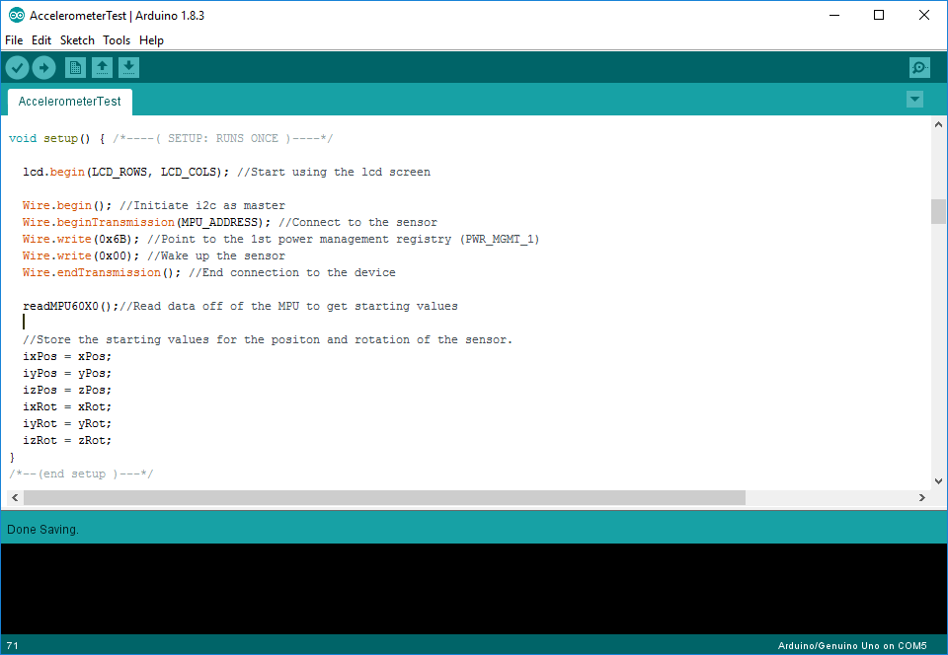
The next major part of the code, the loop() function runs continuously on the UNO after setup()is completed. Almost all of this section deals with displaying data to the LCD screen. A guide to using LCD screens and LCD keypad shields can be found in the “Using Your LCD Keypad Shield” guide at www.rabbitrobots.com. Since this guide is concerned with how to use the MPU-60X0 and other I²C devices, the “readMPU60X0()” function that is called in loop()will be analyzed instead.
The readMPU60X0()function (fig. 5) sets the values of the first set of short variables to the data returned by the sensor. It first re-connects to the MPU-60X) with the line: “Wire.beginTransmission(MPU_ADDRESS);” Then, the device points to the first sensor data registry (ACCEL_XOUT_H) with the line “Wire.write(0x3B);” The UNO then stops trying to write data to the MPU, but keep control of it with “Wire.endTransmission(false);” The “false” passed into the function specifies that the UNO should send a “reset” command instead of a “stop” when disconnecting, keeping it in control of the MPU so other devices cannot access it.
Fig. 5
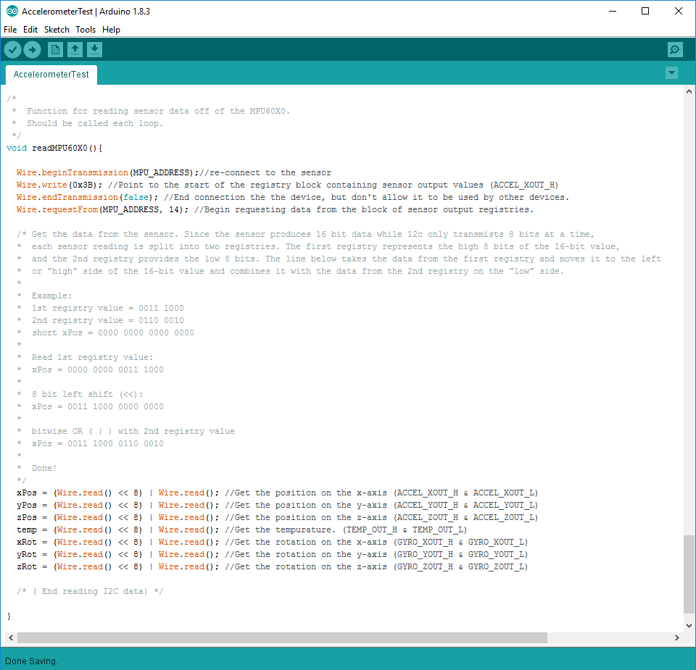
The actual reading of data begins with “Wire.requestFrom(MPU_ADDRESS, 14);” This line sends a command to the MPU to request 14 bytes, or registries, of data. Each byte of data represents one registry and calling “Wire.read()” will read the data from the registry and move onto the next one until all of the requested bytes have been read. All of the sensor data registries are consecutive, so they can all be read in one go.
However, since the MPU-60X0 is supposed to give 16-bit data, but can only store 8 bits (1 byte) of data in a registry, some math has to be done to read the data properly. Each dataset is stored as a “high” and “low” part that contain the first and last 8 bits of the 16-bit of the data respectively. Each variable has to be assigned to the combination of these two registries in order to be read correctly. This is done in the program using this operation:
“value =(Wire.read() << 8) | Wire.read()”
That can look pretty frightening, so let’s break it down step-by-step. Operations in parentheses, “(“ and “)” are done first, so the operation Wire.read() << 8 is carried out first. Wire.read()returns the 8 bits of data stored in the current registry, which should contain the “high” portion of the data, and performs a left shift 8 bits long on it. What a left shift does is shift the binary representation of a value to the left by the specified number of bits. For example, an 8-bit left shift of the number 0000000011001010 would be 1100101000000000. The number of zeros to the left is important because if a number goes beyond those zeros, it “disappears” and defaults to zero. Since a 16-bit variable is being assigned, there is just enough space for the left shift to complete without going too far to the left.
The following operation “| Wire.read()” performs a bitwise OR with the second registry, the “low” registry, with the data that was just left-shifted. A bitwise OR changes the binary representation of a value by checking each bit in both values to see if either of them are “1.” If either of the bits in the two values are “1”, that bit will be assigned to “1.” Otherwise, “0” will be assigned to that bit. For example, a bitwise OR with 01100001 and 01000100 would be 01100101. Since the right half of the 16-bit value should be empty from the left shift done earlier, the bitwise OR will just assign the value of the second registry to the “low” half of the 16-bit value.
This operation is performed with each variable to produce a usable value, concluding how to read data from the MPU-60X0.

